Name: Jatvish Yechuri
Reg no: 220905246
Roll no: 36
CSE – C
Title: CD Lab – 3 & 4
Date: 22/1/2025

sample program: Write a program in ‘C’ to identify the arithmetic and relational operators from the given input ‘C’ file.

Code:
#include<stdio.h>
#include<string.h>
#include<stdlib.h>
int main()
{
char c,buf[10];
FILE *fp=fopen("digit.c","r");
c = fgetc(fp);
if (fp == NULL)
{
printf("Cannot open file \n");
exit(0);
}
while(c!=EOF)
{
int i=0;
buf[0]='\0';
if(c=='=')
{
buf[i++]=c;
c = fgetc(fp);
if(c=='=')
{
buf[i++]=c;
buf[i]='\0';
printf("\n Relational operator : %s",buf);
}
else
{
buf[i]='\0';
printf("\n Assignment operator: %s",buf);
}
}
else
{
if(c=='<'||c=='>'||c=='!')
{
buf[i++]=c;
c = fgetc(fp);
if(c=='=')
{
buf[i++]=c;
}
buf[i]='\0';
printf("\n Relational operator : %s",buf);
}
else
{
buf[i]='\0';
}
}
c = fgetc(fp);
}}

Screenshots:
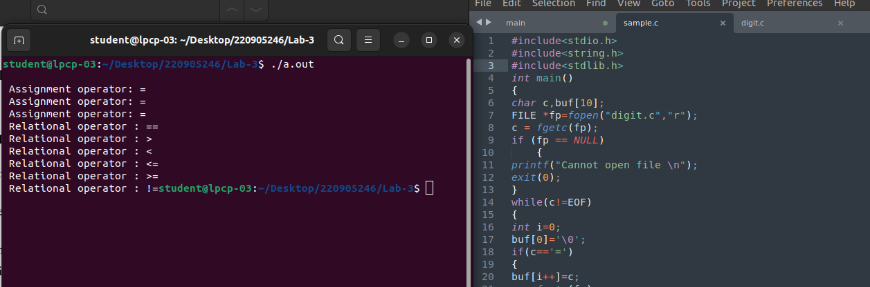

Q1. Write functions to identify the following tokens.
a. Arithmetic, relational and logical operators.
b. Special symbols, keywords, numerical constants, string literals and identifiers.

Code:

#include <stdio.h>
#include <stdlib.h>
#include <string.h>
#include <ctype.h>

#define MAX_TOKEN_LEN 100

int isKeyword(const char *word) {
const char *keywords[] = {
"int", "float", "char", "double", "if", "else", "while", "for", "return", "void", "struct", "break"
};
for (int i = 0; i < sizeof(keywords) / sizeof(keywords[0]); ++i) {
if (strcmp(word, keywords[i]) == 0) return 1;
}
return 0;
}

int isSpecialSymbol(char ch) {
const char specialSymbols[] = {';', ',', '(', ')', '{', '}', '[', ']', '=', '+', '-', '*', '/', '%', '&', '|', '!', '<', '>'};
for (int i = 0; i < sizeof(specialSymbols); ++i) {
if (ch == specialSymbols[i]) return 1;
}
return 0;
}

int isLogicalOperator(const char *op) {
return (strcmp(op, "&&") == 0 || strcmp(op, "||") == 0 || strcmp(op, "!") == 0);
}

int isRelationalOperator(const char *op) {
return (strcmp(op, "==") == 0 || strcmp(op, "!=") == 0 || strcmp(op, "<") == 0 || strcmp(op, "<=") == 0 || strcmp(op, ">") == 0 || strcmp(op, ">=") == 0);
}

int isArithmeticOperator(const char *op) {
return (strcmp(op, "+") == 0 || strcmp(op, "-") == 0 || strcmp(op, "*") == 0 || strcmp(op, "/") == 0 || strcmp(op, "%") == 0);
}

void printToken(const char *lexeme, const char *type) {
printf("<%s, %s>\n", lexeme, type);
}

void identifyTokens(FILE *file) {
char buffer[MAX_TOKEN_LEN];
int bufIndex = 0;
char ch;

while ((ch = fgetc(file)) != EOF) {

if (isspace(ch)) {
if (bufIndex > 0) {
buffer[bufIndex] = '\0';
if (isKeyword(buffer)) {
printToken(buffer, "Keyword");
} else if (isdigit(buffer[0])) {
printToken(buffer, "Numeric Constant");
} else {
printToken(buffer, "Identifier");
}
bufIndex = 0;
}
continue;
}

if (ch == '"') {
if (bufIndex > 0) {
buffer[bufIndex] = '\0';
if (isKeyword(buffer)) {
printToken(buffer, "Keyword");
} else if (isdigit(buffer[0])) {
printToken(buffer, "Numeric Constant");
} else {
printToken(buffer, "Identifier");
}
bufIndex = 0;
}

buffer[bufIndex++] = ch;
while ((ch = fgetc(file)) != '"' && ch != EOF) {
buffer[bufIndex++] = ch;
}
if (ch == '"') {
buffer[bufIndex++] = ch;
buffer[bufIndex] = '\0';
printToken(buffer, "String Literal");
}
continue;
}

if (isSpecialSymbol(ch)) {
if (bufIndex > 0) {
buffer[bufIndex] = '\0';
if (isKeyword(buffer)) {
printToken(buffer, "Keyword");
} else if (isdigit(buffer[0])) {
printToken(buffer, "Numeric Constant");
} else {
printToken(buffer, "Identifier");
}
bufIndex = 0;
}
char symbol[2] = {ch, '\0'};
printToken(symbol, "Special Symbol");
continue;
}

buffer[bufIndex++] = ch;
}

if (bufIndex > 0) {
buffer[bufIndex] = '\0';
if (isKeyword(buffer)) {
printToken(buffer, "Keyword");
} else if (isdigit(buffer[0])) {
printToken(buffer, "Numeric Constant");
} else {
printToken(buffer, "Identifier");
}
}
}

int main() {
const char *fileName = "1_input.c";

FILE *file = fopen(fileName, "r");
if (file == NULL) {
perror("Error opening file");
return 1;
}

printf("Tokens from the file %s:\n", fileName);
identifyTokens(file);

fclose(file);

return 0;
}

Screenshots:

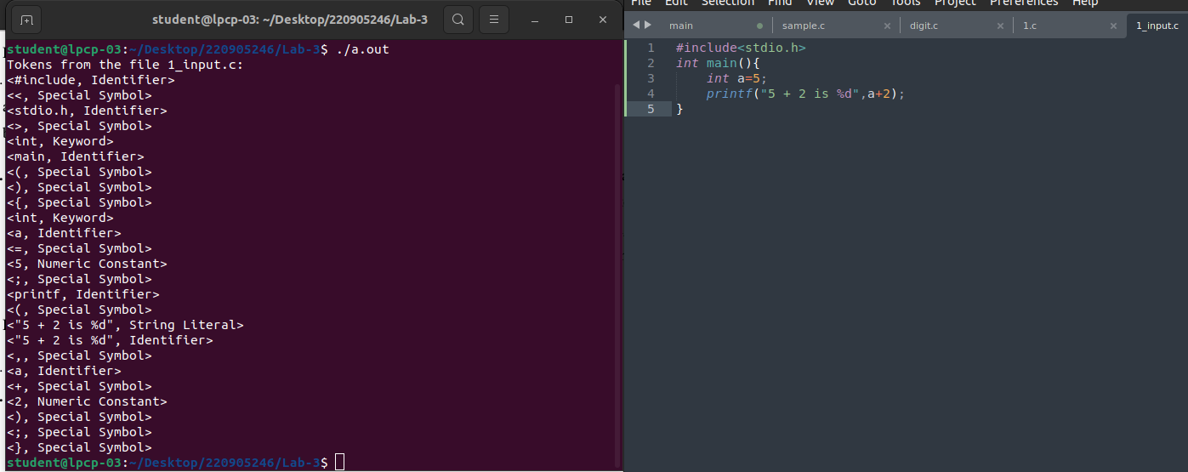

Q2) Design a lexical analyzer that includes a getNextToken() function for processing a simple C program.The analyzer should construct a token structure containing the row number, column number, and token type for each identified token. The getNextToken() function must ignore tokens located within single-line or multi-line comments, as well as those found inside string literals. Additionally, it should strip out preprocessor directives.

Code:
#include <stdio.h>
#include <stdlib.h>
#include <string.h>
#include <ctype.h>

#define MAX_TOKEN_LEN 100

typedef enum {
KEYWORD, IDENTIFIER, NUMERIC_CONSTANT, STRING_LITERAL, SPECIAL_SYMBOL, OPERATOR, COMMENT, PREPROCESSOR
} TokenType;

typedef struct {
TokenType type;
char lexeme[MAX_TOKEN_LEN];
int row;
int col;
} Token;

int isKeyword(const char *word) {
const char *keywords[] = {
"int", "float", "char", "double", "if", "else", "while", "for", "return", "void", "struct", "break"
};
for (int i = 0; i < sizeof(keywords) / sizeof(keywords[0]); ++i) {
if (strcmp(word, keywords[i]) == 0) return 1;
}
return 0;
}

int isSpecialSymbol(char ch) {
const char specialSymbols[] = {';', ',', '(', ')', '{', '}', '[', ']', '=', '+', '-', '*', '/', '%', '&', '|', '!', '<', '>'};
for (int i = 0; i < sizeof(specialSymbols); ++i) {
if (ch == specialSymbols[i]) return 1;
}
return 0;
}

int isPreprocessorDirective(char *line) {
return line[0] == '#';
}

void printToken(Token token) {
const char *types[] = { "Keyword", "Identifier", "Numeric Constant", "String Literal", "Special Symbol", "Operator", "Comment", "Preprocessor" };
printf("<%s, %s, Line: %d, Column: %d>\n", token.lexeme, types[token.type], token.row, token.col);
}

int getNextToken(FILE *file, Token *token, int *line, int *col) {
char ch;
char buffer[MAX_TOKEN_LEN];
int bufIndex = 0;
int isString = 0;
int isComment = 0;

while ((ch = fgetc(file)) != EOF && isspace(ch)) {
if (ch == '\n') {
(*line)++;
*col = 0;
} else {
(*col)++;
}
}

if (ch == EOF) return 0;

if (ch == '/' && (ch = fgetc(file)) == '/') {
isComment = 1;
while ((ch = fgetc(file)) != EOF && ch != '\n');
if (ch == '\n') (*line)++;
return 1;
}

if (ch == '/' && (ch = fgetc(file)) == '*') {
isComment = 1;
while ((ch = fgetc(file)) != EOF && (ch != '*' || (ch = fgetc(file)) != '/'));
return 1;
}

if (ch == '"') {
isString = 1;
buffer[bufIndex++] = ch;
while ((ch = fgetc(file)) != EOF && ch != '"') {
buffer[bufIndex++] = ch;
(*col)++;
}
buffer[bufIndex++] = '"';
buffer[bufIndex] = '\0';
token->type = STRING_LITERAL;
strcpy(token->lexeme, buffer);
token->row = *line;
token->col = *col;
return 1;
}

if (ch == '#') {
buffer[bufIndex++] = ch;
while ((ch = fgetc(file)) != EOF && ch != '\n') {
buffer[bufIndex++] = ch;
(*col)++;
}
buffer[bufIndex] = '\0';
token->type = PREPROCESSOR;
strcpy(token->lexeme, buffer);
token->row = *line;
token->col = *col;
return 1;
}

if (isalpha(ch) || ch == '_') {
buffer[bufIndex++] = ch;
(*col)++;
while ((ch = fgetc(file)) != EOF && (isalnum(ch) || ch == '_')) {
buffer[bufIndex++] = ch;
(*col)++;
}
buffer[bufIndex] = '\0';
if (isKeyword(buffer)) {
token->type = KEYWORD;
} else {
token->type = IDENTIFIER;
}
strcpy(token->lexeme, buffer);
token->row = *line;
token->col = *col;
return 1;
}

if (isdigit(ch)) {
buffer[bufIndex++] = ch;
(*col)++;
while ((ch = fgetc(file)) != EOF && isdigit(ch)) {
buffer[bufIndex++] = ch;
(*col)++;
}
buffer[bufIndex] = '\0';
token->type = NUMERIC_CONSTANT;
strcpy(token->lexeme, buffer);
token->row = *line;
token->col = *col;
return 1;
}

if (isSpecialSymbol(ch)) {
buffer[bufIndex++] = ch;
buffer[bufIndex] = '\0';
token->type = SPECIAL_SYMBOL;
strcpy(token->lexeme, buffer);
token->row = *line;
token->col = *col;
(*col)++;
return 1;
}

if ((ch == '=' || ch == '&' || ch == '|') && (ch = fgetc(file)) != EOF) {
buffer[bufIndex++] = ch;
(*col)++;
if (ch == '=' || ch == '&' || ch == '|') {
buffer[bufIndex++] = ch;
buffer[bufIndex] = '\0';
token->type = OPERATOR;
strcpy(token->lexeme, buffer);
token->row = *line;
token->col = *col;
return 1;
}
}

return 0;
}

void identifyTokens(FILE *file) {
Token token;
int line = 1, col = 1;
while (getNextToken(file, &token, &line, &col)) {
if (token.type != COMMENT) {
printToken(token);
}
}
}

int main() {
const char *fileName = "2_input.c";

FILE *file = fopen(fileName, "r");
if (file == NULL) {
perror("Error opening file");
return 1;
}

printf("Tokens from the file %s:\n", fileName);
identifyTokens(file);

fclose(file);

return 0;
}

Screenshots:

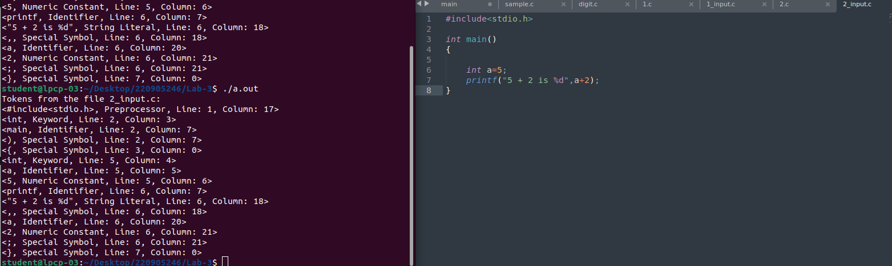
c

LAB 4:

Q) Using getNextToken( ) implemented in Lab No 3, design a Lexical Analyser to implement the following symbol tables.
Parameters : S.No,Lexeme name,token type,data type ,size.

Code:

#include <stdio.h>
#include <stdlib.h>
#include <string.h>
#include <ctype.h>

#define MAX_TOKEN_LEN 100
#define MAX_SYMBOLS 100

typedef enum {
KEYWORD, IDENTIFIER, NUMERIC_CONSTANT, STRING_LITERAL, SPECIAL_SYMBOL, OPERATOR, COMMENT, PREPROCESSOR, FUNCTION
} TokenType;

typedef struct {
char lexeme[MAX_TOKEN_LEN];
TokenType type;
char dataType[10];
int size;
} SymbolTableEntry;

SymbolTableEntry symbolTable[MAX_SYMBOLS];
int symbolCount = 0;

const char *keywords[] = {"int", "float", "char", "double", "void", "return", "if", "else", "while", "for", "bool"};
const char specialSymbols[] = {';', ',', '(', ')', '{', '}', '[', ']', '='};
const char operators[] = {'+', '-', '*', '/', '%', '&', '|', '!', '<', '>'};

// Check if a word is a keyword
int isKeyword(const char *word) {
for (int i = 0; i < sizeof(keywords) / sizeof(keywords[0]); ++i) {
if (strcmp(word, keywords[i]) == 0) return 1;
}
return 0;
}

// Get size of a data type
int getSize(const char *dataType) {
if (strcmp(dataType, "int") == 0) return 4;
if (strcmp(dataType, "float") == 0) return 4;
if (strcmp(dataType, "char") == 0) return 1;
if (strcmp(dataType, "double") == 0) return 8;
if (strcmp(dataType, "bool") == 0) return 1; // Added size for bool
return 0;
}

// Add entry to symbol table if not already present
void addToSymbolTable(const char *lexeme, TokenType type, const char *dataType, int size) {
for (int i = 0; i < symbolCount; i++) {
if (strcmp(symbolTable[i].lexeme, lexeme) == 0) return; // Avoid duplicates
}
strcpy(symbolTable[symbolCount].lexeme, lexeme);
symbolTable[symbolCount].type = type;
strcpy(symbolTable[symbolCount].dataType, dataType);
symbolTable[symbolCount].size = size;
symbolCount++;
}

// Check if character is a special symbol
int isSpecialSymbol(char ch) {
for (int i = 0; i < sizeof(specialSymbols); ++i) {
if (ch == specialSymbols[i]) return 1;
}
return 0;
}

// Check if character is an operator
int isOperator(char ch) {
for (int i = 0; i < sizeof(operators); ++i) {
if (ch == operators[i]) return 1;
}
return 0;
}

// Check if it's a preprocessor directive
int isPreprocessorDirective(const char *buffer) {
return buffer[0] == '#'; // Checks if the line starts with '#'
}

// Process input file and tokenize
void processFile(FILE *file) {
char buffer[MAX_TOKEN_LEN];
char lastKeyword[MAX_TOKEN_LEN] = "";
int ch, index = 0;
TokenType lastTokenType = IDENTIFIER; // Track the last token type

while ((ch = fgetc(file)) != EOF) {
// Handle preprocessor directive on its own
if (ch == '#') {
// Start building preprocessor directive
buffer[index++] = ch;
while ((ch = fgetc(file)) != EOF && !isspace(ch)) {
buffer[index++] = ch;
}
buffer[index] = '\0'; // Null terminate the string
printf("<%s, Preprocessor Directive>\n", buffer);
addToSymbolTable(buffer, PREPROCESSOR, "-", 0); // Store preprocessor directive
index = 0;
}
// Handle other tokens
else if (isspace(ch) || isSpecialSymbol(ch) || isOperator(ch)) {
if (index > 0) {
buffer[index] = '\0';

if (isPreprocessorDirective(buffer)) {
printf("<%s, Preprocessor Directive>\n", buffer);
addToSymbolTable(buffer, PREPROCESSOR, "-", 0); // Store preprocessor directive
} else if (isKeyword(buffer)) {
printf("<%s, Keyword>\n", buffer);
strcpy(lastKeyword, buffer);
addToSymbolTable(buffer, KEYWORD, buffer, getSize(buffer)); // Store keyword
lastTokenType = KEYWORD; // Update last token type
} else if (isdigit(buffer[0])) {
printf("<%s, Numeric Constant>\n", buffer);
addToSymbolTable(buffer, NUMERIC_CONSTANT, "int", 4); // Store numeric constant
lastTokenType = NUMERIC_CONSTANT; // Update last token type
} else if (lastTokenType == IDENTIFIER && ch == '(') {
printf("<%s, Function>\n", buffer);
addToSymbolTable(buffer, FUNCTION, lastKeyword, getSize(lastKeyword)); // Store function
lastTokenType = FUNCTION; // Update last token type
} else {
printf("<%s, Identifier>\n", buffer);
addToSymbolTable(buffer, IDENTIFIER, lastKeyword, getSize(lastKeyword)); // Store identifier
lastTokenType = IDENTIFIER; // Update last token type
}
index = 0;
}

if (isSpecialSymbol(ch)) {
char sym[2] = {ch, '\0'};
printf("<%c, Special Symbol>\n", ch);
addToSymbolTable(sym, SPECIAL_SYMBOL, "-", 0); // Store special symbol
} else if (isOperator(ch)) {
char op[2] = {ch, '\0'};
printf("<%c, Operator>\n", ch);
addToSymbolTable(op, OPERATOR, "-", 0); // Store operator
}
} else if (ch == '"') { // String Literal Start
buffer[index++] = ch; // Add the opening "
while ((ch = fgetc(file)) != EOF && ch != '"') {
buffer[index++] = ch;
}
buffer[index++] = '"'; // Add the closing "
buffer[index] = '\0';
printf("<%s, String Literal>\n", buffer);
addToSymbolTable(buffer, STRING_LITERAL, "-", 0); // Store string literal
index = 0;
} else {
buffer[index++] = ch;
}
}
}

// Print the symbol table
void printSymbolTable() {
printf("\nSymbol Table:\n");
printf("------------------------------------------------------\n");
printf("| SI_NO | Lexeme | Token Type | Data Type | Size |\n");
printf("------------------------------------------------------\n");
for (int i = 0; i < symbolCount; i++) {
char *tokenType;
switch (symbolTable[i].type) {
case KEYWORD: tokenType = "Keyword"; break;
case IDENTIFIER: tokenType = "Identifier"; break;
case NUMERIC_CONSTANT: tokenType = "Numeric Constant"; break;
case STRING_LITERAL: tokenType = "String Literal"; break;
case SPECIAL_SYMBOL: tokenType = "Special Symbol"; break;
case OPERATOR: tokenType = "Operator"; break;
case FUNCTION: tokenType = "Function"; break;
case PREPROCESSOR: tokenType = "Preprocessor"; break;
default: tokenType = "-";
}
printf("| %-5d | %-7s | %-18s | %-9s | %-4d |\n",
i + 1, symbolTable[i].lexeme, tokenType,
symbolTable[i].dataType, symbolTable[i].size);
}
printf("------------------------------------------------------\n");
}

int main() {
FILE *file = fopen("1_input.c", "r");
if (!file) {
perror("Error opening file");
return 1;
}

printf("Tokens Identified:\n");
processFile(file);
fclose(file);

printSymbolTable();
return 0;
}

Screenshot:

